***Experiment 6 Output***

Raw data was **cleaned and transformed** before being loaded into the data warehouse, ensuring consistency, accuracy, and completeness.

***Creating Tables***

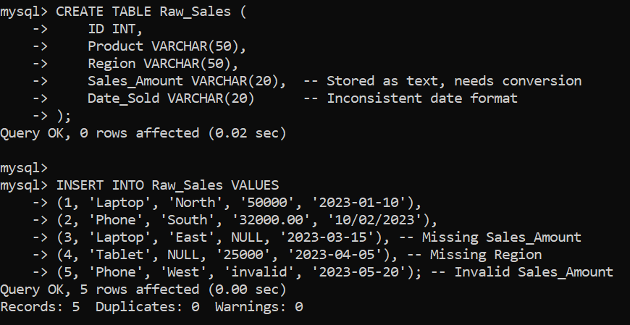

***Fig 2: Creating Tables and Inserting Data***

***Creating Database and Using in MySQL***

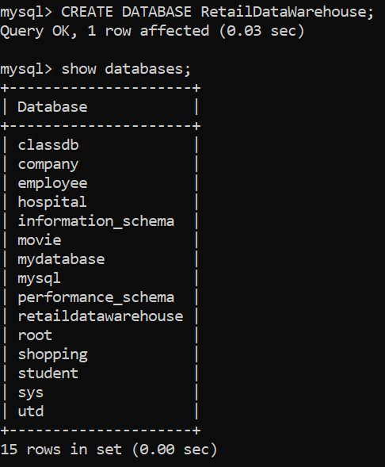

***Fig 1: Database in MySQL***

***Extracting and Transforming Data***

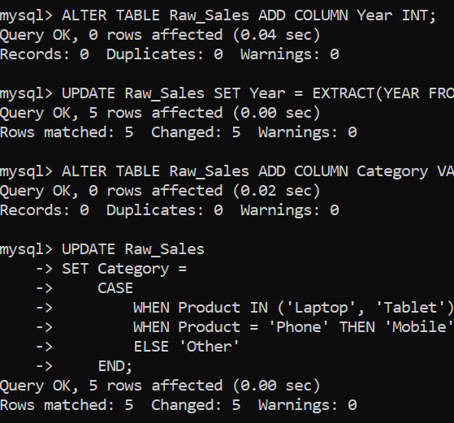

***Loading data after cleaning***

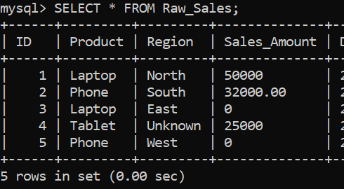

***Fig 3: Extraction and Transformation of Data***

***Fig 4: Cleaned data for warehouse***